Karan Parmar - S11198967

Aditi Sodagar- S11194519

Asheel Rai Chand - S11171901

|  |  |
| --- | --- |
| CS218 Assignment 2  MuscleTrack | Group Members: |

# Changes in Scope

The recommendation block that is suggesting basic workout plan as stated in the scope in assignment 2 has not been implemented, instead the app has a list of pre-stored audio (songs) to keep the user motivated for gym. The app also has a splash screen displayed during the starting with the app logo displayed on it.

# Activities

## Main Activity

Main Activity (home page) shown with some dummy data. The user can update and delete exercise in the same fragment.

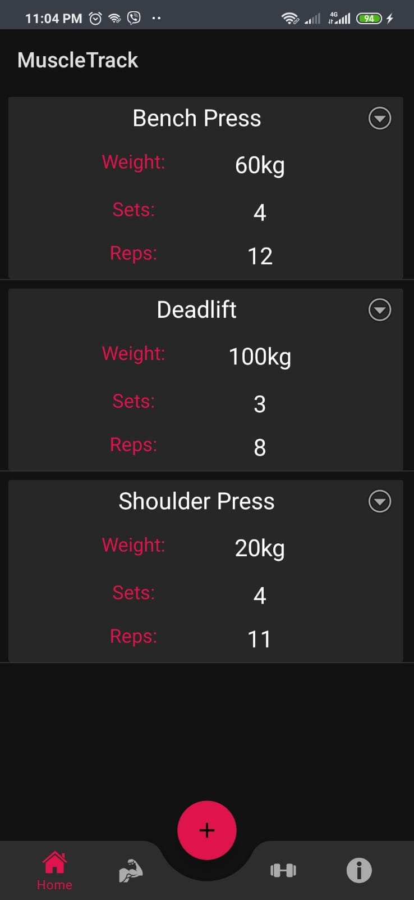

## Add Exercise Activity

Users can click the “plus” button to view this activity. This activity will allow users to add exercise which will then be stored and retrieved from the local database.

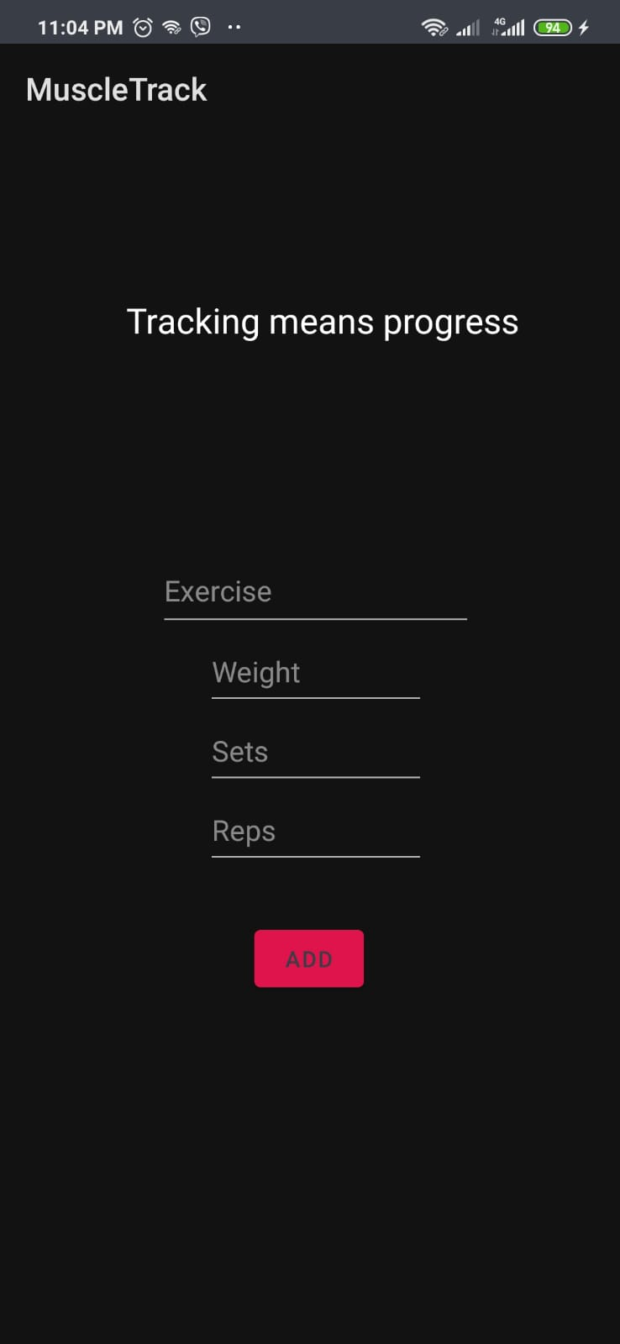

# Motivation Fragment

This fragment will display a list (Recycler view) of some quotes from famous gym trainers to keep the users motivated to go gym.

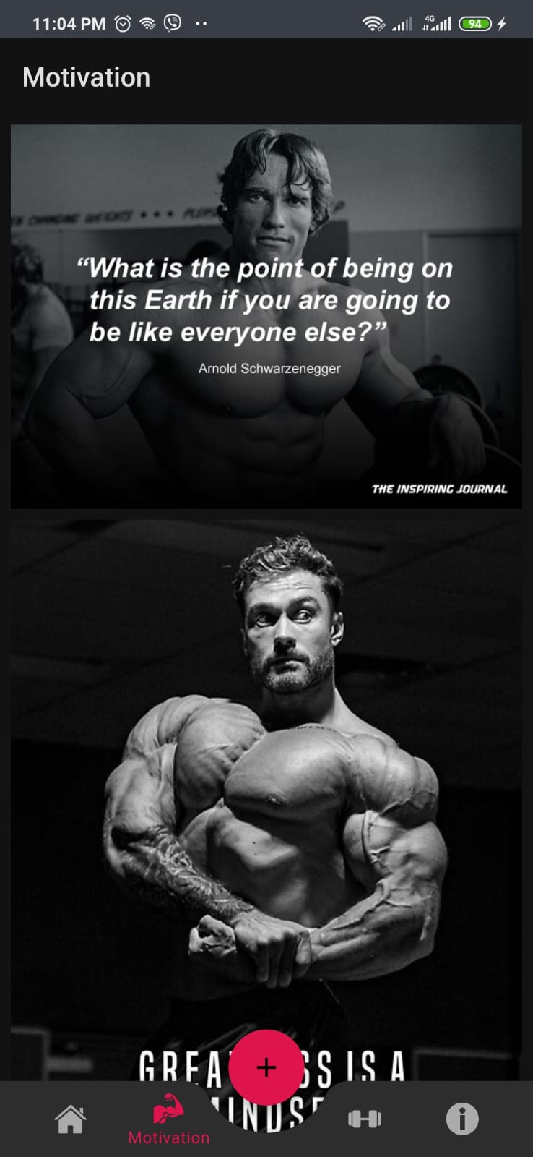

# About Us Fragment

This fragment will give a brief overview of what the app does and the main mission behind this app.

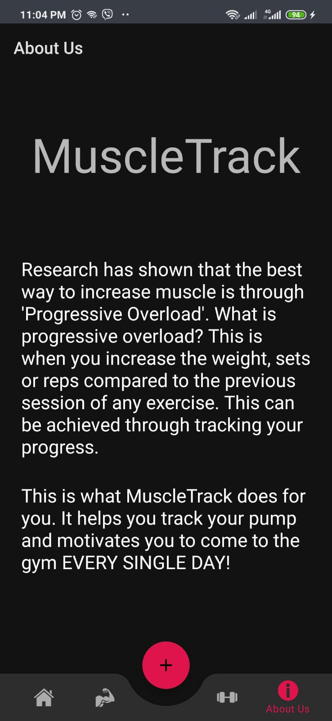

# Music Fragment

This fragment allows the users to listen to our gym playlist which keeps them motivated everyday.

